# CS 255 System Design Document Template

This template lays out all the different sections that you need to complete for Project Two. Each section has guidance to prompt your thinking. You will need to continually reference the interview transcript as you work to make sure that you are addressing your client’s needs. There is no required length for the final document. Instead the goal is to complete each section based on what your client’s needs are. Remove this note when you are finished, and replace all bracketed text with the relevant information.

## UML Diagrams

### UML Use Case Diagram

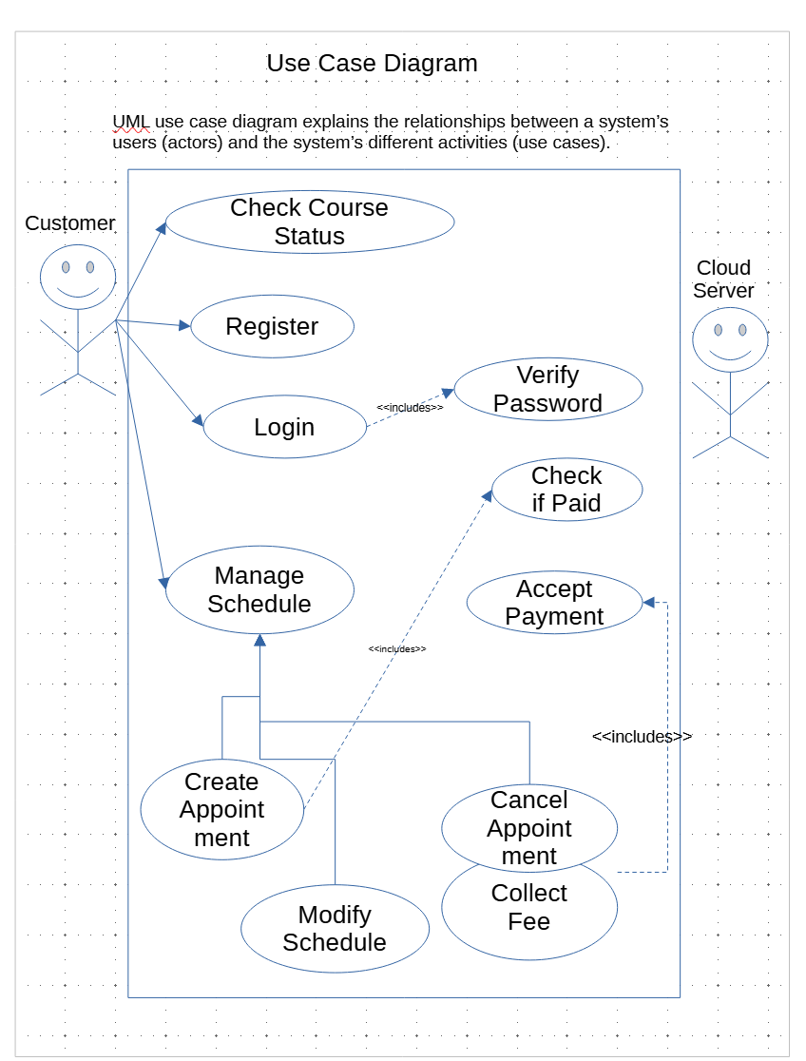

### UML Activity Diagrams

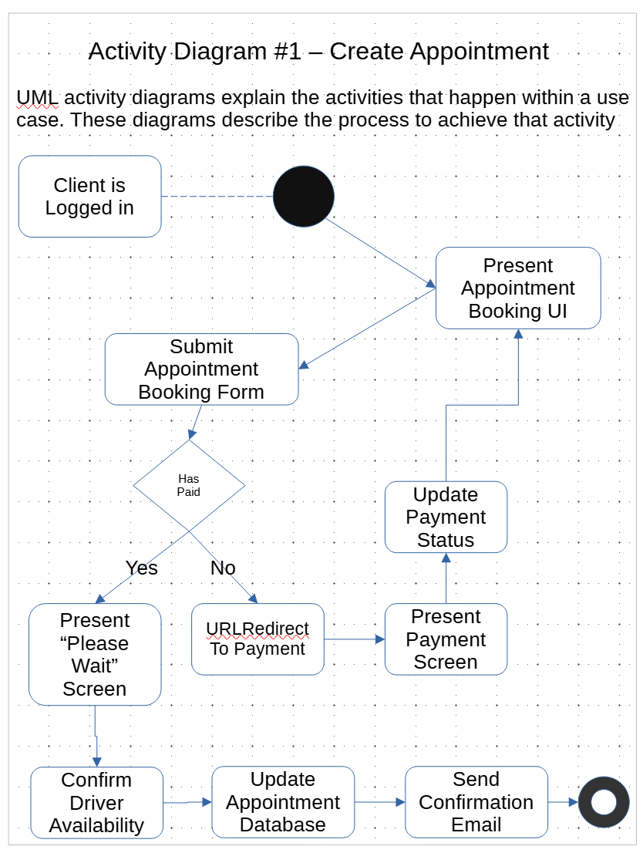

### 

### UML Sequence Diagram

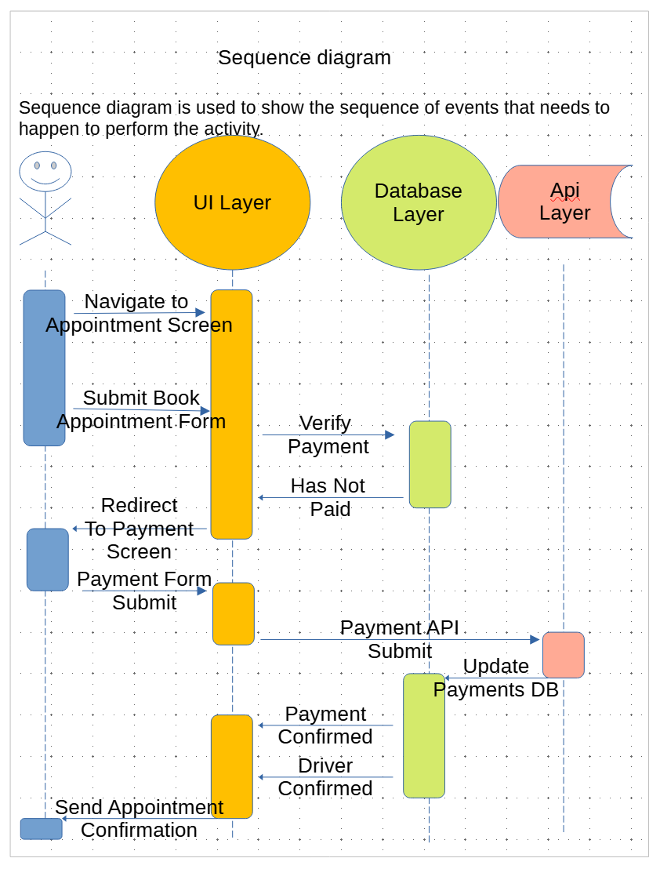

### UML Class Diagram

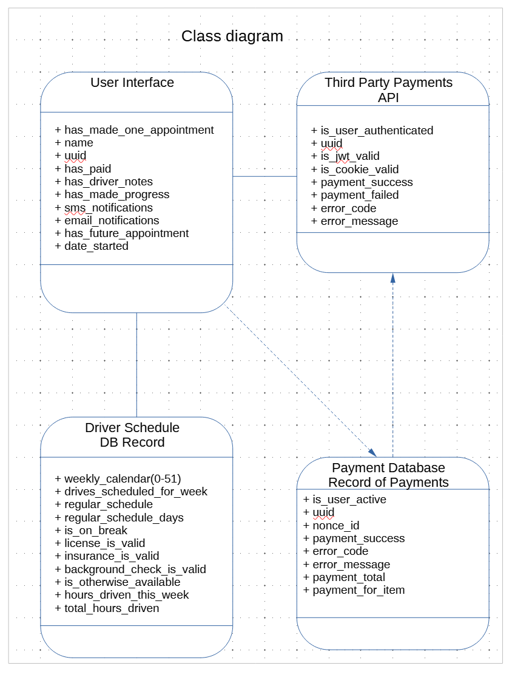

## Technical Requirements

Our system will depend upon a number of hardware and cloud based systems to accomplish the goal set forth by Driver Pass. We will require a number of cloud based PaaS features to facilitate the accepting of calls and may use Twilio. For accepting payments we’ll rely on a third party provider Stripe. To minimize hardware configuration concerns we will rely on Microsoft Azure Cloud Infrastructure for Virtual Machines, Containerization, Cloud Functions, Postgres databases, and perhaps even virtual desktops for consistency and role based access.